# Greece – Script Instruction

**URL:** <https://search.et.gr/el/>

## Initial Setup

1. Open the URL.
2. On the landing page, select “Smart Search”.

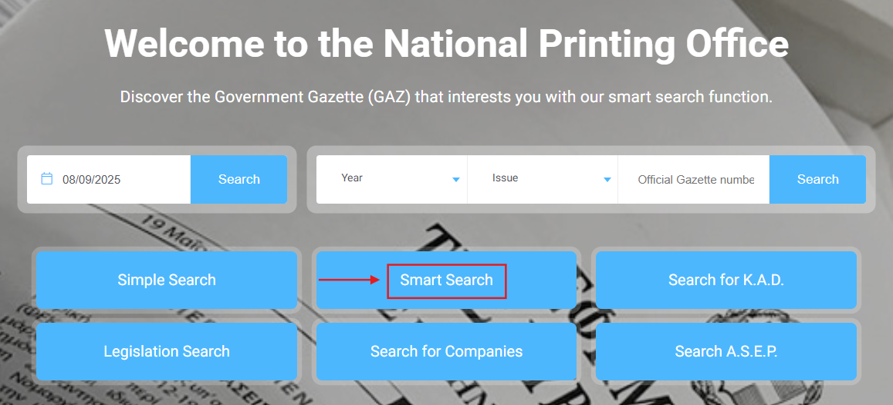

## Advanced Search Setup

1. On the landing page, click “Applying Filters” to display more filters for the search.

1. Set the Entity Type filter to “Law”.

## Extraction of Metadata

1. After setting the filters, enter Greek keywords into the “Text to Search” field with quotation marks then click the Search button. (*Please refer to the list of keywords file.*)

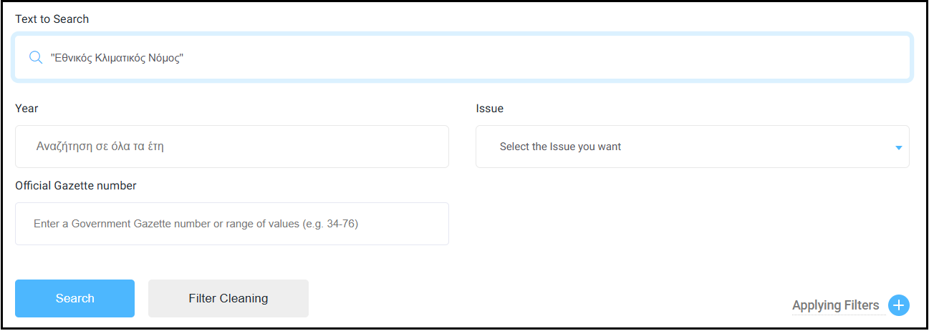

1. For example, entering “Εθνικός Κλιματικός Νόμος” (national climate law) returns [109 results](https://search.et.gr/el/advanced-search/?advancedSearch=%2522%25CE%2595%25CE%25B8%25CE%25BD%25CE%25B9%25CE%25BA%25CF%258C%25CF%2582%2520%25CE%259A%25CE%25BB%25CE%25B9%25CE%25BC%25CE%25B1%25CF%2584%25CE%25B9%25CE%25BA%25CF%258C%25CF%2582%2520%25CE%259D%25CF%258C%25CE%25BC%25CE%25BF%25CF%2582%2522&selectedEntities=JTVCJTVE).
2. The search results are displayed in a structured table format and the metadata is readily available.
3. Extract the following metadata from the table:

**Source Link** – retrieve this from the hyperlink embedded in the download icon within the Download column, labeled in red.

**Original Title** – click the document icon within the Summary column, labeled in red.

Extract the original title from the sentence ending with a period, as shown below.

**Type of Regulation** – as the Entity Type was set to “Law” during filtering, set this to “Law”.

**Date of Adoption** – extract this from the Official Gazette date, labeled in blue. The date format in the platform is in DD-MM-YYYY. You should change this to YYYY-MM-DD in the output.

**Entry into Force Date** – extract this from the Traffic date, labeled in purple. The date format in the platform is in DD-MM-YYYY. You should change this to YYYY-MM-DD in the output.

## Important Reminders

1. Duplicate titles and/or source links should be removed and retain one copy of each duplicate.
2. Follow this date format for consistency – YYYY-MM-DD.
3. Add one column beside the Original Title and translate the titles into English.
4. Please exclude any legislations containing the following Hungarian terms in the title:

* οικειοποίηση (appropriation)
* προϋπολογισμός (budget)
* καταργήθηκε (repealed)
* ανακλήθηκε (revoked)
* αεροδρόμιο (airport)
* αερογραμμή (airline)
* καθορισμένος (appointed)
* κορωνοϊός (coronavirus) / COVID-19

For any queries, issues, or clarifications regarding these instructions, kindly post them promptly on our Teams channel so we can provide a timely response or action as needed.

[ESG KLI Project | ESG KLI Project | Microsoft Teams](https://teams.microsoft.com/l/channel/19%3A2cb71aBrx0vDiOIeb2XNrxxCN2EoVFDjq_GOAxRevDY1%40thread.tacv2/ESG%20KLI%20Project?groupId=6f8eb5d6-d2c9-4fe4-a2b2-16b14d6fcc9a&tenantId=be92c534-7b60-4630-bc01-ec5122548d47)